Tech Spec: Account Statements
Author/s: Sujan AdigaSajid Shaikh
Team/Pod: Payouts | BU: RazorpayX
Published Date: May 30, 2024

Reviewer Name | Reviewed Date | Status
 |  | Not started
 |  | Not started

Table of Contents

1. Problem Statement 2
2. Introduction & Scope 3
2.1. Relevant Resources 3
3. Out of Scope 3
4. Futuristic Scope 3
5. Assumptions, Goals & Non-Goals 4
5.1. Assumptions 4
5.2. Goals 4
5.3. Non-Goals 4
6. Current Architecture / Current HLD 4
7. Final Approach - Specifications 5
7.1. Specifications 6
7.1.1. Account Statement Fetch 6
7.1.1. Account Statement Linking 7
Initial Implementation - ART reconciliation [Reverted] 8
Final Implementation 8
7.2. Assumptions 8
7.3. Possibility of Open Sourcing 8
7.4. Possibility on Patent 8
7.5. Data model/Schema Changes 9
7.5.1 Existing Schema 9
7.5.2 Proposed Schema 11
7.6. Business Logic Changes 15
7.6.1 APIs 15
7.7. Miscellaneous Questions 16
8. Non Functional Requirements (NFRs) 16
8.1. Scalability 16
8.2. Availability 17
8.3. Security 18
8.4. Compliance 18
8.5. Reliability 18
8.6. Infra Cost 19
9. Feature Dependencies & SLAs 19
9.1. Upstream Dependencies 19
9.2. Downstream Dependencies 20
10. Testing Plan 20
10.1. Test Cases 20
10.2. UAT Testing 21
10.3. Performance/Load testing 21
11. Go-live plan 21
11.1. Production Rollout and Ramp plan 21
11.2. Backward Compatibility 21
11.3. Rollback plan 22
12. Monitoring & Logging 22
13. Milestones & Timelines 22
14. Glossary 23
15. Appendix 23

1. Problem Statement
Context:

To make Payouts, a merchant must have a bank account linked to their RazorpayX account. There are two types of accounts available:

RazorpayX Lite: A digital account created in RazorpayX for businesses to start accepting payments within a short span of time.

Current Account: An account that offers all standard banking features like cheque book, debit card and account statements.

Details of the all the transactions made on these accounts are provided to merchants on the RazorpayX Dashboard under the "Account Statement" section, additionally they can also be accessed using Transaction APIs

To support RazorpayX Lite accounts, RazorpayX uses an RBL Bank pool account with support from the internal Ledger service (CLS) to track transactions and balances. And to support Current Accounts, RazorpayX has integrations with multiple bank accounts: RBL, Yes Bank, ICICI Bank and AXIS Bank. Here, bank APIs are used to provide account statements to merchants.

For Current Accounts, the Account Statements fetched from the banks are also linked with Payout transactions in the system based on various parameters and this cross linking is also used to reconcile the status of Payout transactions.

Problem Statement:

For Current Accounts, the entire infrastructure around fetching Account Statements from Banks and linking them with Payout transactions is housed within API monolith application. As part of API decomposition, we're moving this infrastructure out of API monolith into its own microservice.

2. Introduction & Scope
This document covers the details of functionalities moved (What?):

- Account Statement Fetch from respective banks for Current Accounts
- Account Statement Linking and Reconciliation for Current Accounts
- APIs around Account Statements for both the Current and Lite accounts

and the approach (How?) and the plan (When?) of movement.

2.1. Relevant Resources
- Account Statement Strategy Doc
- X Payouts API Decomp and ReArchiecture

3. Out of Scope
Details of migration of Account Balance out of API monolith is not part of this document. That will be taken up separately.

4. Futuristic Scope
- Addition of other sources such as fund loading, consolidated payouts etc for reconciliation.
- Reconciliation of sub account payouts.

5. Assumptions, Goals & Non-Goals

5.1. Assumptions
- Payouts will be the only source to be reconciled with the fetched statements as of now.

5.2. Goals
- Account Statement Fetch and Linking functionalities to be moved out of API monolith
- APIs around Account Statements to be moved out of API monolith
- SLA of T+1 day for linking Current Account Statements with Payout transactions
- Onboarding of CA merchants to be moved out of API monolith.
- Pool account statement fetch to be moved out of API monolith.
- API cut-off

5.3. Non-Goals
Not applicable.

6. Current Architecture / Current HLD

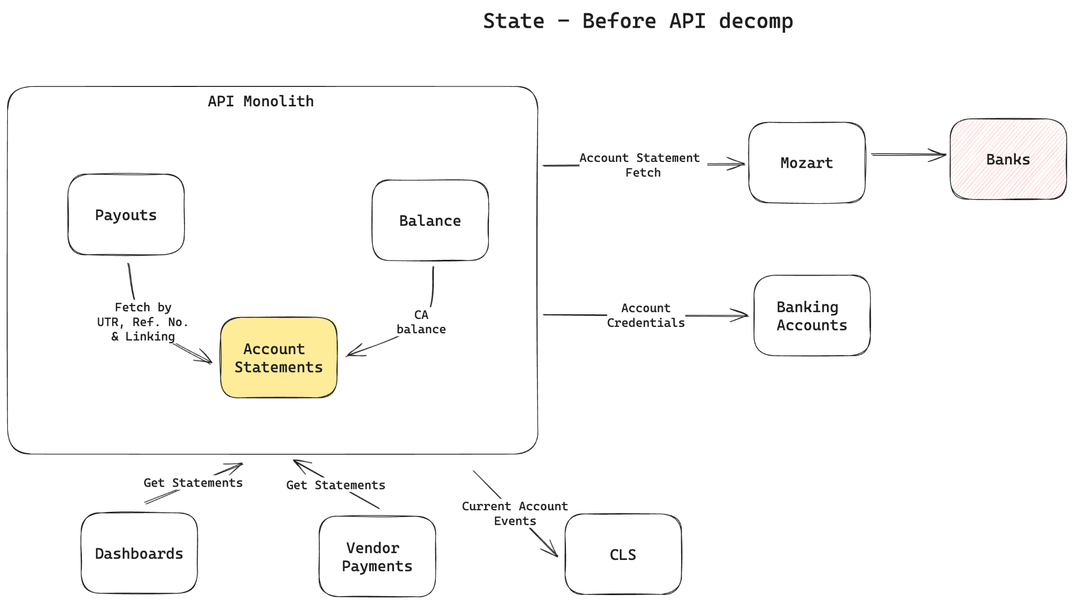

Account Statement resides as a module within API monolith. For Current Accounts, statements are fetched on a regular basis using Bank APIs via Mozart. Credentials to make these Bank API calls are fetched from Banking Accounts service.

Linking of Account Statements to Payout transactions also happen within API monolith, there are background jobs that perform this activity and this linking is done in two ways - Payout records will have reference to linked Account Statement records, and Account Statement records will have reference to linked Payout or Payout reversals.

Account Statements that are not linked with any Payout transactions are marked as External transactions. And records in the "external" table in API monolith are created for these records. Also, for all the Account Statement records, a record in "transactions" table in API monolith are created and upon linking, the same is notified to CLS (Central Ledger Service) via SNS (these events are sent asynchronous considering high volume)

Additionally, there are APIs provided to merchants to query Account Statements and there APIs used internally by Dashboards and internal apps (Vendor Payments) to access Account Statement transactions.

On top of this, reconciliation of Account Statement with the Payout data is done on a daily basis using ART.

7. Final Approach - Specifications

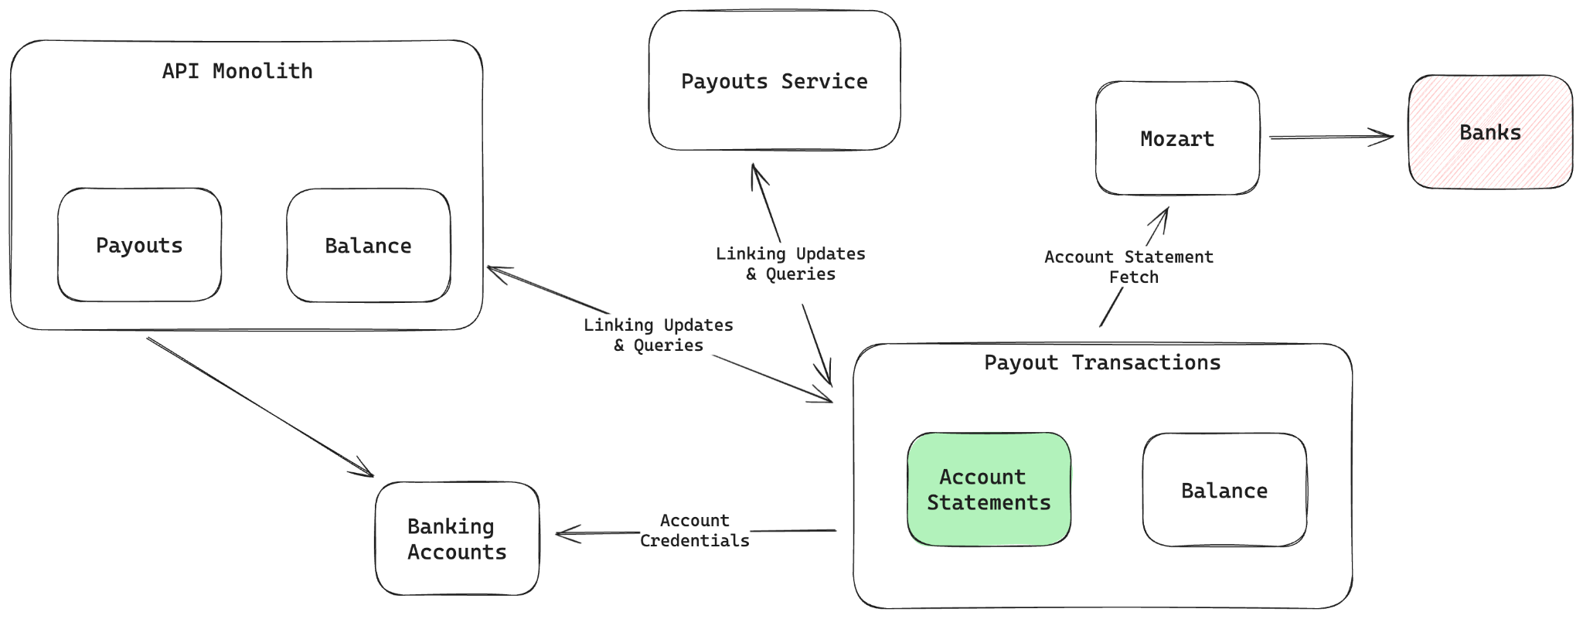

The core responsibility of Account Statement service is to "reliably provide account statements to its end users - merchants". For Lite accounts, Account Statements are powered by the Central Ledger Service (CLS), however for Current Accounts, Banks will be the source of truth for Account Statements.

While providing Account Statements for Current Accounts, we can't fetch the statements on-demand from Banks though. Primary reason for this is the limitations in the Bank infrastructure to support this level of load; secondly, we would also need these transactions in our own datastores for us to run reconciliation scripts on a regular basis. This means, for Current Accounts, we will have to have a setup to fetch / sync Account Statements from Banks to our datastores.

Additionally, the Account Statements feature is pitched to merchants as a tool that aids in reconciliation. Hence, we will attempt to link Account Statement transactions with transactions happening in the RazorpayX ecosystem on that account - Payouts, Payout Reversals and Fund Loading transactions (Fund Loading transactions are not linked today).

Combined, Account Statement service can be seen to have 3 core modules:
- Fetch: Responsible for fetching latest Account Statement transactions from the banks on a regular basis
- Linking: Responsible for enriching Account Statement transactions by linking them to different transaction sources
- Reports and APIs: Provides interfaces for merchants to access their Account Statements

7.1. Specifications

7.1.1. Account Statement Fetch
There are 6500+ Current Accounts in the system today, and this number will grow. And we have a T+1 day SLA with merchants to provide enriched Account Statements to them - this means, a transaction happening on day T in their account should be available to them to access with transaction source linking (if applicable) on the next day. Considering throughput limitations at the Bank end, we won't be able to fetch statements for all the Current Accounts at once on regular intervals - instead Accounts will have to be picked on a rotational basis.

Following is the process followed for Account Statement fetch from banks:
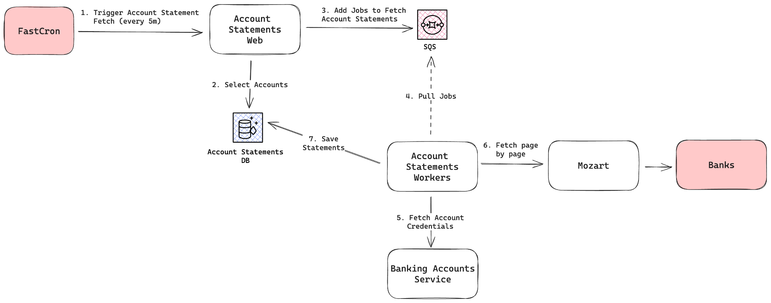

Cron Job via FastCron will be configured to run every 5 minutes and will have control to limit the number of Accounts picked in a run - this will be tuned to ensure we're able to process all the Accounts before the next run. The Cron Job will trigger an API endpoint in Account Statements that picks Accounts for which statement fetch from the Bank needs to be done and sends an SQS message with the details of the Account.

In each run a portion of the bandwidth (configurable) will be allocated to fetch Account Statements which have activity in the recent past. Account Balance, timestamp at which the Account Balance was last updated, Statement Closing Balance, timestamp at which the Statement Closing Balance was last updated will be used to identify Accounts that have activity in the recent past.

Messages from the SQS queue are read by a group of workers, and they fetch up to a certain number of pages of Account Statements from Banks. During this interaction, Account Credentials needed to make authenticated calls to Banks are fetched from Banking Accounts Service, and calls to Banks happen via Mozart.

Before saving the Account Statements received from Banks, there will be a deduplication done using certain fields in the statement transaction records to omit inserting any transactions that are already saved.

7.1.1. Account Statement Linking
Different approaches are discussed here: Account Statement Service

Linking Account Statement transactions with different transactional sources can be seen as shared responsibility of Account Statements service and the corresponding Transaction source(ex: Payouts)

Since linking needs both sets of the data to be available, it would be better done at a place where access to both the datasets - Account Statements and Transactions are available. One of the places where this is true is the Recon tool - ART. Since there will be scripts in ART to match the same sets of data on a daily basis for reconciliation purposes already, we will have to only build workflows to send the matched output to the Account Statements service.

Initial Implementation - ART reconciliation [Reverted]
As part of decomp from API monolith, we had implemented the solution which utilizes ART for reconciliation purposes [Option 4 here]. Post reconciliation, ART would send the reconciliation report to a configured endpoint so that we can then accordingly link these to the statements in Payout service. However, we encountered issues during ART reconciliation where recon was failing almost everyday due to high memory load on recon workers. Additionally, we had a dependency on the recon team to get this sorted and the statement was being delayed everyday. Due to increase in data volumes or factors outside the control of Account Statements service, time taken to complete reconciliation in ART can increase over time and we would not be able to guarantee our SLA of providing enriched Account Statements in T+1 days. Hence, using ART for a live and somewhat real time use case like this is not ideal.

Final Implementation
The recommended approach will be Option 6.3 here with some modifications:
- Data from DB will be backed up in the data lake.

7.2. Assumptions
None.

7.3. Possibility of Open Sourcing
Not applicable.

7.4. Possibility on Patent
Not applicable.

7.5. Data model/Schema Changes

7.5.1 Existing Schema
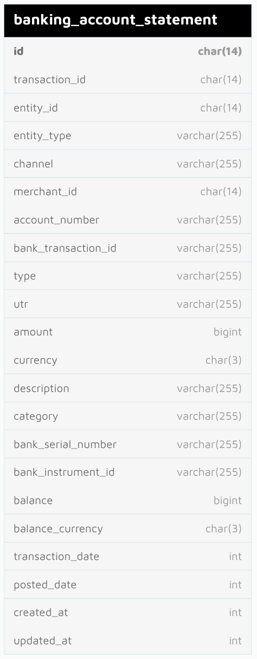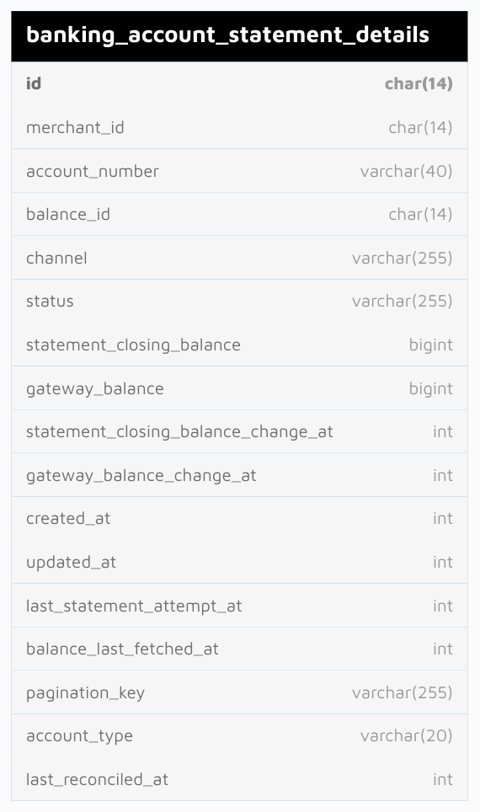

Ref: https://dbdiagram.razorpay.com/dbdiagram/fetch/8d7865c6-287d-11ef-9070-b6b2b4bf913b
Table: banking_account_statement
Columns:
- id: Primary Key
- transaction_id: Refers to transactions table in API
- entity_id and entity_type: Together identify a transaction source, ex: payout and <payout_id>
- channel: Identifies the Bank, ex values: rbl, icici
- merchant_id: Identifies the Merchant
- account_number: Account number of the Current / Pool account
- bank_transaction_id: Transaction id from Bank as per Account Statements
- type: Type of transaction - credit / debit
- utr: Alphanumeric code generated by banks when a transaction is executed
- amount: Transaction amount in Paise
- currency: Transaction currency, ex: INR
- description: Transaction description as shared by the bank. Ex: "UPI/409418312234/FTS AXIS F/ABCD.RZPX@HDFCBANK"
- category: Transaction category shared by the Bank. One of values: customer_initiated, bank_initiated, cash_withdrawal, cash_deposit, others
- bank_serial_number: Transaction serial number as shared by the Bank
- bank_instrument_id: Unused column. Not being filled
- balance: Account Balance as per the current transaction
- balance_currency: Balance currency, ex: INR
- transaction_date: Transaction date in unix timestamp. Ex: 1718169490
- posted_date: Transaction timestamp in unix timestamp. Ex: 1718169490
- created_at and updated_at: Row created and updated timestamps in unix timestamp
Indexes:
- account_number
- created_at
- updated_at
- merchant_id
- bank_transaction_id
- entity_id
- transaction_id
- (merchant_id, created_at)
- utr
- (account_number, posted_date)
Table: banking_account_statement_details
Columns:
- id: Primary Key
- merchant_id: Identifies the Merchant
- account_number: Account number of the Current / Pool account
- balance_id: Refers to balance table in API monolith. Identifies "banking" balance for this Account
- channel: Identifies the Bank, ex values: rbl, icici
- status: Account status, used to figure out if statement fetch is to be done or not. One of values: active, inactive, under_maintenance, archived. Statement fetch is done only for "active" accounts
- statement_closing_balance: Closing Balance as per the last account statement transaction fetched thus far
- gateway_balance: Account Balance fetched using Bank APIs
- statement_closing_balance_change_at: Timestamp at which statement_closing_balance was last updated
- gateway_balance_change_at: Timestamp at which gateway_balance was last updated
- created_at and updated_at: Row created and updated timestamps in unix timestamp
- last_statement_attempt_at: Timestamp when latest attempt to fetch Account Statements was made
- balance_last_fetched_at: Timestamp at which Account Balance was last fetched
- pagination_key: Pagination key shared by Banks to identify the cursor till which the Account Statements are fetched thus far. Format: <last_transaction_posted_date>_<actual_pagination_key_from_banks>. Last transaction posted_date is prefixed to the pagination key to identify the freshness of Pagination Key
- account_type: Used to identify if it's a Current Account or Pool Account. Value will be "direct" for Current Accounts and "shared" for Pool Accounts
- last_reconciled_at: Timestamp at which last reconciliation for the missing statement transactions was made
Indexes:
- (account_number, channel) - unique
- (account_number, channel)
- last_reconciled_at

7.5.2 Proposed Schema
Ref: https://dbdiagram.razorpay.com/dbdiagram/fetch/be7f7a52-2890-11ef-9b63-ca1c6da2170c

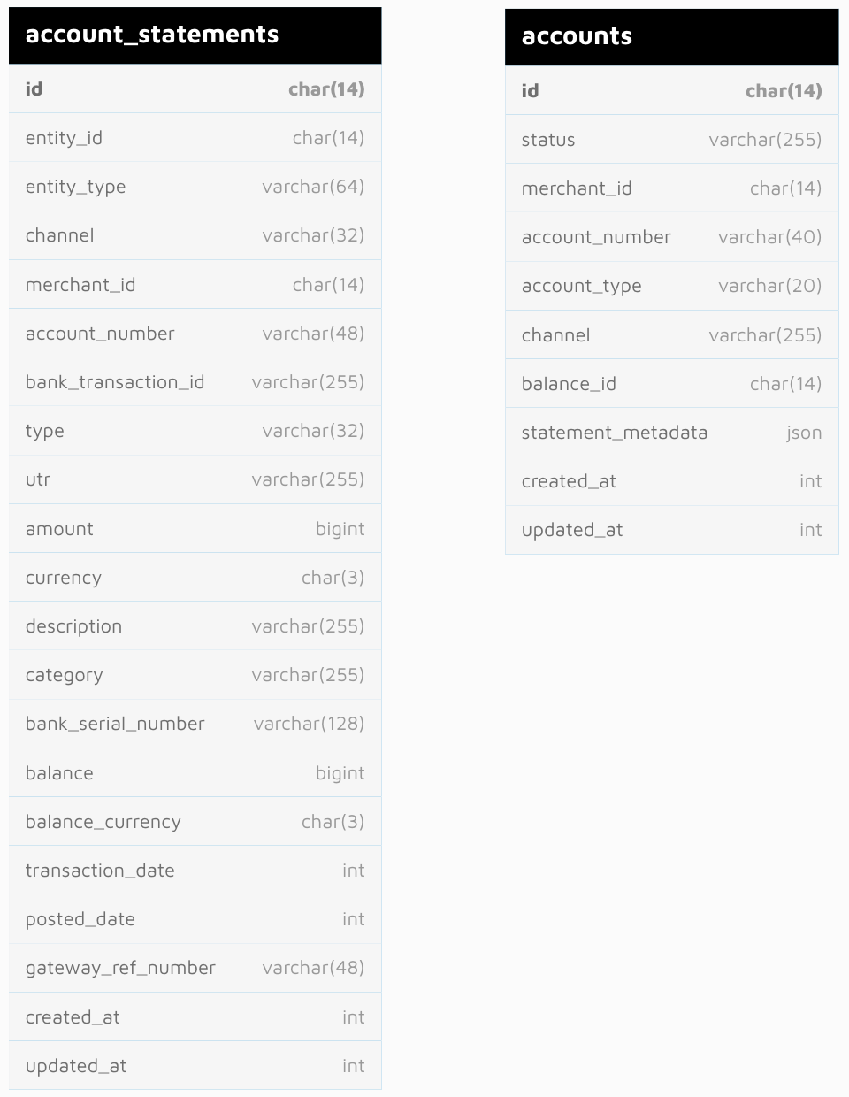

Table: banking_account_statement => account_statements
Columns:
- id: Primary Key
- transaction_id: Refers to transactions table in API
(Account Statements will no longer create transaction records in API)
- entity_id and entity_type: Together identify a transaction source, ex: payout and <payout_id>
- channel: Identifies the Bank, ex values: rbl, icici
- merchant_id: Identifies the Merchant
- account_number: Account number of the Current / Pool account
- bank_transaction_id: Transaction id from Bank as per Account Statements
- type: Type of transaction - credit / debit
- utr: Alphanumeric code generated by banks when a transaction is executed
- amount: Transaction amount in Paise
- currency: Transaction currency, ex: INR
- description: Transaction description as shared by the bank. Ex: "UPI/409418312234/FTS AXIS F/ABCD.RZPX@HDFCBANK"
- category: Transaction category shared by the Bank. One of values: customer_initiated, bank_initiated, cash_withdrawal, cash_deposit, others
- bank_serial_number: Transaction serial number as shared by the Bank
- bank_instrument_id: Unused column. Not being filled
- balance: Account Balance as per the current transaction
- balance_currency: Balance currency, ex: INR
- transaction_date: Transaction date in unix timestamp. Ex: 1718169490
- posted_date: Transaction timestamp in unix timestamp. Ex: 1718169490
- gateway_ref_number: Reference number sent from transaction sources extracted from the transaction description. Ex: RZPNU18CJAY9S
- created_at and updated_at: Row created and updated timestamps in unix timestamp
Indexes:
- (account_number, posted_date)
- created_at
- updated_at
- merchant_id
- bank_transaction_id
- entity_id
- transaction_id
- (merchant_id, created_at)
- utr
- gateway_ref_number
Table: banking_account_statement_details => accounts
Columns:
- id: Primary Key
- status: Account status, used to figure out if statement fetch is to be done or not. One of values: active, inactive, under_maintenance, archived. Statement fetch is done only for "active" accounts
- merchant_id: Identifies the Merchant
- account_number: Account number of the Current / Pool account
- account_type: Used to identify if it's a Current Account or Pool Account. Value will be "direct" for Current Accounts and "shared" for Pool Accounts
- channel: Identifies the Bank, ex values: rbl, icici
- balance_id: Refers to balance table in API monolith. Identifies "banking" balance for this Account
- created_at and updated_at: Row created and updated timestamps in unix timestamp
- statement_closing_balance: Closing Balance as per the last account statement transaction fetched thus far
(Moved to statement_metadata)
- gateway_balance: Account Balance fetched using Bank APIs
(Will be moved to the balance module)
- statement_closing_balance_change_at: Timestamp at which statement_closing_balance was last updated
(Moved to statement_metadata)
- gateway_balance_change_at: Timestamp at which gateway_balance was last updated
(Will be moved to the balance module)
- last_statement_attempt_at: Timestamp when latest attempt to fetch Account Statements was made
(Moved to statement_metadata)
- balance_last_fetched_at: Timestamp at which Account Balance was last fetched
(Will be moved to the balance module)
- pagination_key: Pagination key shared by Banks to identify the cursor till which the Account Statements are fetched thus far. Format: <last_transaction_posted_date>_<actual_pagination_key_from_banks>. Last transaction posted_date is prefixed to the pagination key to identify the freshness of Pagination Key
(Moved to statement_metadata)
- last_reconciled_at: Timestamp at which last reconciliation for the missing statement transactions was made
(Not needed anymore, if needed in the future, will be added under statement_metadata)
- statement_metadata: JSON holding additional data needed to fetch and work with Account Statements. Will have the following fields in the initial version:
  - statement_closing_balance: Closing Balance as per the last account statement transaction fetched thus far
  - statement_closing_balance_change_at: Timestamp at which statement_closing_balance was last updated
  - pagination_key: Pagination key shared by Banks to identify the cursor till which the Account Statements are fetched thus far. Format: <last_transaction_posted_date>_<actual_pagination_key_from_banks>. Last transaction posted_date is prefixed to the pagination key to identify the freshness of Pagination Key
  - last_statement_attempt_at: Timestamp when latest attempt to fetch Account Statements was made
Indexes:
- (account_number, channel) - unique
- merchant_id
- balance_id

7.6. Business Logic Changes

7.6.1 APIs
API | Initiate Account Statement Fetch  API triggered by FastCron to initiate Account Statement fetch for Current Accounts using Bank APIs
Request  POST | http://payouts-ext.razorpay.com/v1/cron/banking_account_statement/fetch/initiate  {  "account_rate_limit": 300,  "account_type": "direct",  "channel": "rbl",  "inactive_duration_limit": 3600,  "reserve_percentage": 95  }  account_rate_limit: Number of Accounts picked to initiate statement fetch. Default: 6  account_type: Type of accounts to be picked. "direct" is for Current Accounts. Default: "direct"  channel: Bank identifier. Allowed: ["rbl"]  inactive_duration_limit: Time in seconds used to figure out activeness of Accounts. 3600 means, if an Account has any transactions in the last 3600 seconds, it will be considered active. Default: 3600  reserve_percentage: In every cron trigger, a portion of Accounts picked are the ones which are active. This value signifies the percentage of Accounts picked which are active. Ex: when the value is 95, 95% active and 5% other Accounts are picked.
Headers | Authorization: Basic <FastCron Credentials>  Content-Type: application/json  Accept: application/json
Response | {  "dispatched_accounts": [  "<account_number_1>",  "<account_number_2>",  "<account_number_3>",  "<account_number_N>"  ]  }

- Pseudocode
- Flowcharts
- Error states
- Failure scenarios
- Conditions that lead to errors and failures
- Limitations

7.7. Miscellaneous Questions

8. Non Functional Requirements (NFRs)

8.1. Scalability
Writes in Account Statements will happen during Statement fetches using Bank APIs and when the statement transactions are linked with transaction sources.

And the read traffic for Account Statements will come from 2 sources:
- Merchants
  - Account Statements on the X dashboard: ~15 RPM
  - Account Statements accessed via Vendor Payments: ~1300 RPM
- Payouts: Fetch account statements using UTR to link a payout to an account statement before taking that payout to terminal state. ~2000 RPM (Expected to be in the same order of number of payouts processed)

Account Statement workloads will be deployed on Kubernetes(k8s). These deployments can be horizontally scaled to a great extent. Heavy workload in Account Statements is with fetching account statements using Bank APIs, this will be managed using background jobs deployed as separate k8s deployments - this can be scaled horizontally as well.

However, with web deployments - that serves HTTP traffic - databases can become a bottleneck when the throughput is high.

Following are the different database operations in context,

Account Statement CREATEs/UPDATEs - will be in the same order of number of transactions happening in the bank accounts. There will be external transactions too (Looking at the past data, ~8% of transactions in bank statements are from outside the RazorpayX ecosystem). However, these CREATEs will be done in batches and in a controlled manner - we control the number of pages fetched from banks, and the number of Accounts acted at once. UPDATEs - linking, though will be event based, however still can be processed in a controlled manner - by Scaling the worker deployments that handle linking in a controlled manner.

Account Statement READs - Fetch by UTR / id - Will be in the same order of Payouts being processed. However, since this comes in the async flow - before taking a payout to a terminal state, latency won't be that critical. Additionally, the query will be on an indexed column and hence will be simple and fast.

Account Statement READs - List statements - ~1300 RPM - Could put load on the Database if this results in scanning a large number of records.

Challenges with READ heavy workload can be addressed by scaling the database cluster with more read replicas based on the need in the future.

8.2. Availability
Account Statements does not come in the critical flow of Payout processing; It's seen as a hygiene feature. Though there will be merchants depending on this for their reconciliation needs, the SLA guarantee is not real time - i.e, T+1 day availability of enriched Account Statements.

Account Statement Fetch: we will have an SLA attempting to fetch fresh statements for every account in the system at least once every 8 hours.

Account Statement Linking: we will have an SLA to link statement transactions with transaction sources within T+1 days

Account Statement Reads: we will aim for an uptime of 99.97% (this is the baseline - as per API monolith routes)

8.3. Security
Account Statements service will be accessed by both internal and external clients.

Internal clients:
- Payouts: to query Account Statements based on UTR or other reference numbers
- Vendor Payments: to access Account Statements to power various merchant experiences

External clients:
- Merchants: via X Dashboard to access Account Statements
- Admin users: via Admin Dashboard, for various admin actions - like force linking a transaction
- FastCron: to trigger statement fetch

Internal clients and FastCron will be authenticated using Basic Auth and there will be checks to ensure which API endpoints can be accessed by which user. On the APIs accessed by FastCron, there will also be IP whitelisting done on FastCron IPs

Calls from Merchants and Admin users will be authenticated at the Edge/Kong layer and the Passport JWT set at that layer will be validated at the Account Statements service. Additionally, for merchant accessed APIs, there will be checks to ensure the merchant is accessing their own data.

8.4. Compliance
Not Applicable.

8.5. Reliability
Account Statements fetched from the Banks will be used for reconciliation purposes at Payouts and other transactional sources. Correctness and complete data being present is hence important.

Banks are the source of truth for this data. Inaccuracies either result due to incorrect responses from the Banks or due to incorrect processing of the data at our end. On the later part, in the initial few days of the migration of Account Statement fetch from API monolith to the new service, we will be running the infra in a shadow mode and comparing the data received at both the places.

Coming to transaction linking / reconciliation, it will be done using more than one parameters in the statement transactions for an accurate matching. Parameters used for matching are:
- Transaction Amount
- UTR
- Transaction mode derived from the description
- posted_date
- Merchant Id

8.6. Infra Cost
Account Statements service will be deployed on Kubernetes. There will be k8s Deployments to handle Web/HTTP traffic, to handle Account Statement Fetch and to handle Account Statement Linking. These deployments will be horizontally scaled using k8s HorizontalPodAutoscalers. Related to this infra, we will have visibility into the infra cost post Performance testing.

For storage, we will need a Database instance. This was already provisioned some time back: prod-aurora-mysql-razorpayx-account-statements-cluster - AWS Aurora cluster with one reader and one writer of type db.t4g.medium - this is costing ~124$ / month

There will be SQS queues needed to fetch and link Account Statements.
Number of messages processed in the Fetch flow will be limited per day - 288 runs / day * 100 messages per run * 30 days = 864K messages
Number of messages processed in the Linking flow will be in the same order of the number of Account Statement transactions fetched. ~500K transactions per day * 30 days = 15M messages
Considering 2 requests (receive message and delete message) per message processed, for 32M requests per month, SQS cost will be ~13$ / month

In the linking flow, we will also store data from different transactional sources if the Account Statements are not available to link them right away. If we choose to store this data for up to 5 days, and if we use DynamoDB - for 15M reads and writes and ~4GB data stored max, this will cost ~25$ / month

9. Feature Dependencies & SLAs

9.1. Upstream Dependencies
Sr. No. | Service | Impact | SLA (if applicable) | POC for service
1 | Mozart | Account Statements won't be able to access Bank APIs to fetch Account Statements
2 | Banking Accounts Service | Account Statements won't be able to fetch credentials needed to make Bank API calls
3 | CLS (via AWS SNS) | Account Statements won't be able to send updates to Ledger when transactions are linked and marked as "external"
4

9.2. Downstream Dependencies
Sr. No. | Service | Impact | SLA (if applicable) | POC for service
1 | Payouts | Payouts won't be able to fetch Account Statement transactions using UTR or gateway ref number before taking Payouts to terminal states - this is a check to avoid money loss when the Payout status received is inconsistent with the Account Statements |  | Arjun Narain
2 | Vendor Payments | Account Statement sync with with Zoho and Tally will be impacted |  | Pavan Kulkarni
3 | Merchant Dashboards | Merchants won't be able to access their Bank Account Statements |  | Person

10. Testing Plan

10.1. Test Cases
Account Statements - Test Cases

10.2. UAT Testing

10.3. Performance/Load testing

11. Go-live plan

11.1. Production Rollout and Ramp plan
Account Statements will be rolled out to merchants in a phased manner. Migration will be first done for the merchants using RBL current accounts (close to 95% of current accounts in the system are on RBL).

Steps in the migration process for RBL accounts:
- Fetch and Processing functionalities
  - Migrate merchants who don't access Account Statement on dashboards - Statements are used only for Reconciliation purposes for these merchants
(This will be done in a shadow manner - meaning, statements will be fetched from both the new system and API monolith, data from both the flows will be compared for correctness)
  - Build dual write capabilities to write the Account Statements fetched from the new system to be written to the API tables
  - Migrate a small portion of merchants and observe the system for any scaling issues - EA (Early Access)
  - Migrate rest of the merchants - GA (General Access)
- Read and Reporting functionalities
  - Pick few merchants and migrate old Account Statement data for them to the new system and enable reads from the new system
  - Slowly ramp up the rollout and observe the system for any scaling issues

11.2. Backward Compatibility
In the first part of the rollout, API monolith will still be the single point of contact for Reads. Data from the new system will be written back to API tables via dual-writes.

And when the reads are migrated, existing API contracts will be kept with few exceptions: APIs used on X Dashboard to list Account Statements have certain filters on linked transactional data. We won't support those filters considering data access limitations and considering they're rarely used. Details: Account Statement Service: Dashboard and Reporting use Cases

11.3. Rollback plan
During the migration, except for the first set of merchants selected where they don't use Account Statements on Dashboards, for the rest of them, Account Statements will be fetched exclusively from one system only - either the new system or API monolith. Switching between these can be done using repurposed "Free Payout Migration" Admin action.
Details: Rollout PS Account Statement EA

Hence, if there is a need to rollback, the Account can be put on "under_maintenance" on the new system and made "active" on API monolith

12. Monitoring & Logging
Following metrics will have to be monitored and necessary alerts will have to be setup:
- Infrastructure
  - Account Statement Fetch worker deployment uptime - monitor number of pods available
  - Backlog in Account Statement Fetch SQS queue should be in check - monitor ApproximateNumberOfMessagesVisible and ApproximateAgeOfOldestMessage AWS SQS metrics
  - Backlog in Dual Writer SQS queue in API should be in check - monitor ApproximateNumberOfMessagesVisible and ApproximateAgeOfOldestMessage AWS SQS metrics
- Account Statement Fetch
  - Activeness of Fetch: Number of account statements being fetched on an hourly basis - to identify uptime issues
  - Fetch performance for active accounts: Monitor when is the last time statement fetch was attempted and deviation between gateway balance and statement closing balances
  - Missed statements: Based on Payouts (as Payout transactions account for 90%+ of account statements)
- Account Statement Linking
  - Linking / Recon percentage: How many statements are linked to transactional sources or marked as external compared to total number of statements
- APIs
  - Error rate
  - Latency

13. Milestones & Timelines

Sr. No. | Title | Owner | JIRA link | Due Date | Reviewer | Status
1 | Account Statements Rollout in shadow mode
2 | Account Statements GA rollout - without reads
3 | Account Statements - Reads migration
4 | Account Statements - API infra cleanup and cut-off

14. Glossary

15. Appendix
- X Payouts API Decomp and ReArchiecture
- Account Statement Service
- CA Balance Fetch - Decomposition

